BASIC TYPE OF DIFFERENTIAL EQUATIONS FROM NCEA PAPERS.

1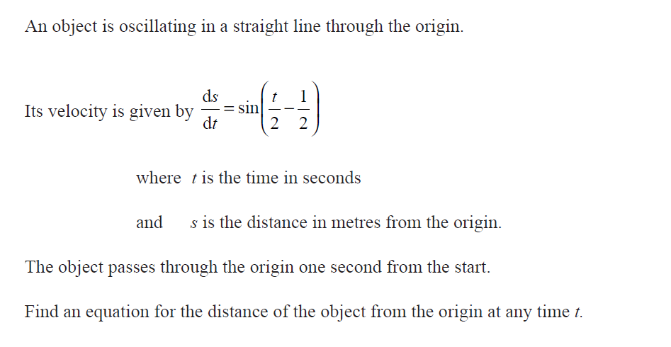

2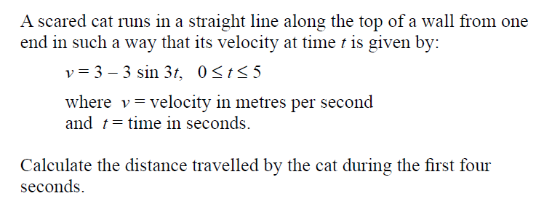
3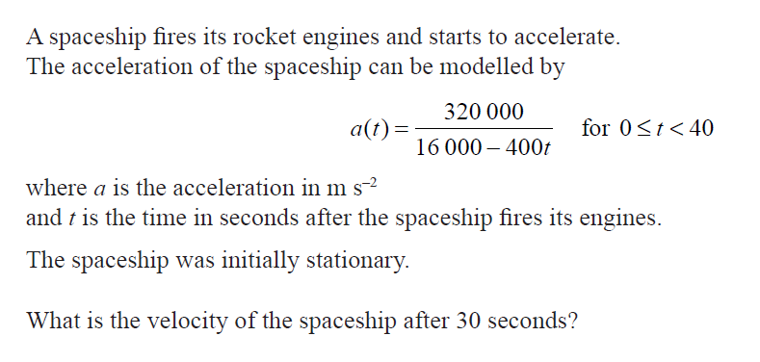

4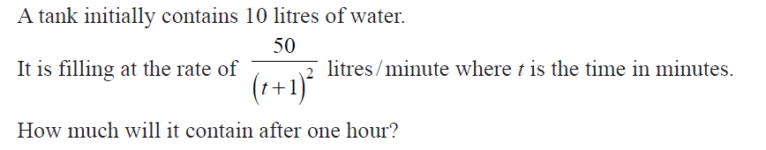
5
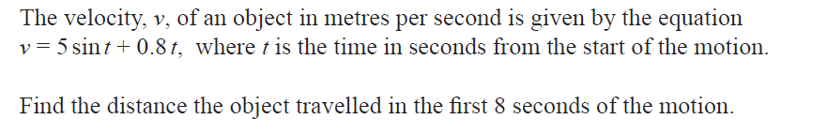

6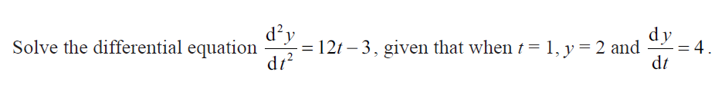
7
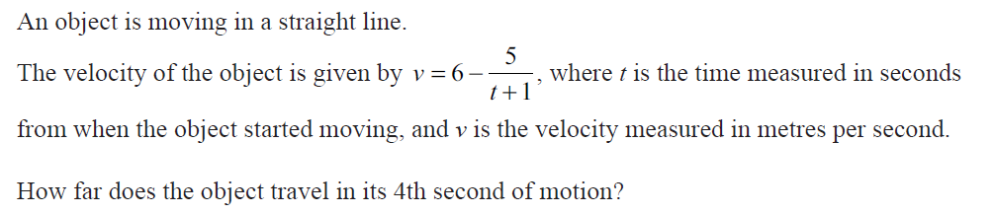

8
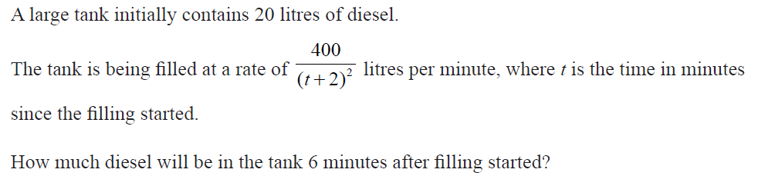

9
