SIMPLE DIFFERENTIAL EQUATIONS FROM NCEA PAPERS.

1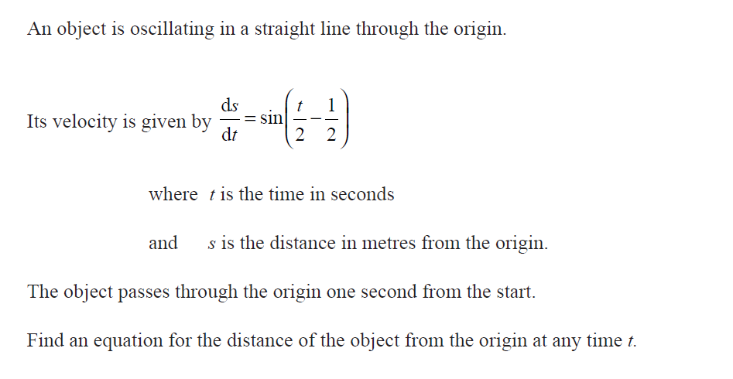
SOLUTION

s = - 2cos( t – 1 ) + c
2 2
Sub t = 1, s = 0
0 = - 2 cos 0 + c
c = 2
s = - 2cos( t – 1 ) + 2
2 2

2
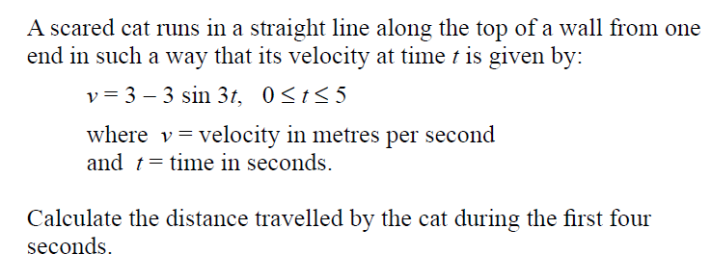

SOLUTION

ds = 3 – 3sin(3t)
dt

s = 3t + cos(3t) + c

when t = 0 s₀ = 0 + cos0 + c = 1 + c
when t = 4 s₄ = 12 + cos12 + c

dist during 4 sec = (12 + cos12 + c) – (1 + c)
= 11 + cos12
= 11.8 m

3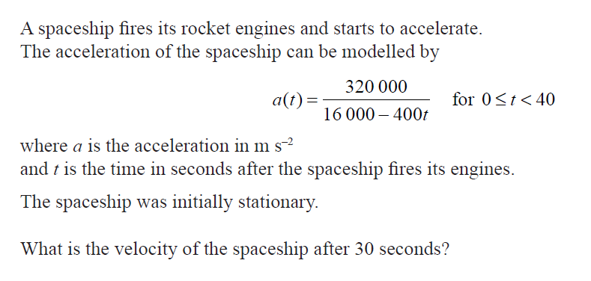

SOLUTION

dv = a = 3200
dt 160 – 4t
v = -800 ln(160 – 4t) + c
sub t = 0, v = 0
0 = -800 ln(160) + c

v = 800ln(160) – 800ln(160 – 4t)

v = 800 ln( 160 )
160 – 4t

Sub t = 30
v = 800 ln( 4 ) = 1109 m/s

4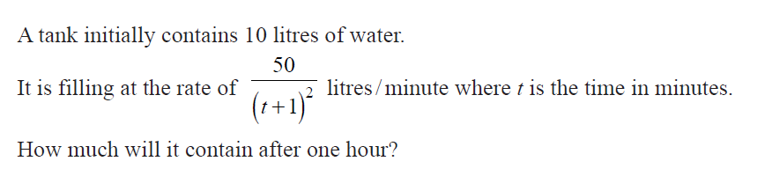

dV = 50 (t + 1) ^{– 2}
dt

V = - 50 (t + 1) ^{– 1} + c

V = -50 + c
(t + 1)
Sub t = 0, V = 10
10 = -50 + c so c = 60
V = -50 + 60
(t + 1)

Sub t = 60 so V = 59.2 L

5
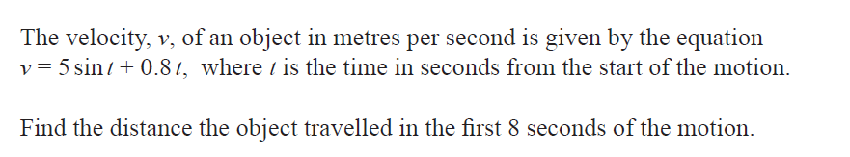

d = -5cos(t) + 0.4t² + c

sub t = 0 d₁ = -5 + c
sub t = 8 d₂ = -5cos8 + .4×8² + c

Dist d₂ – d₁ = -5cos8 + .4×8² + 5 31.3 m

6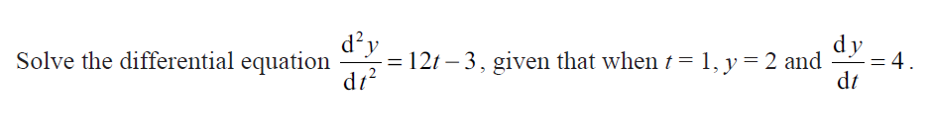
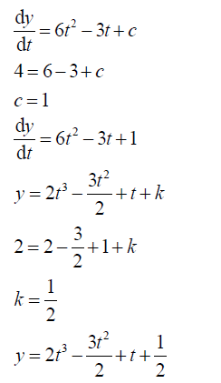

7
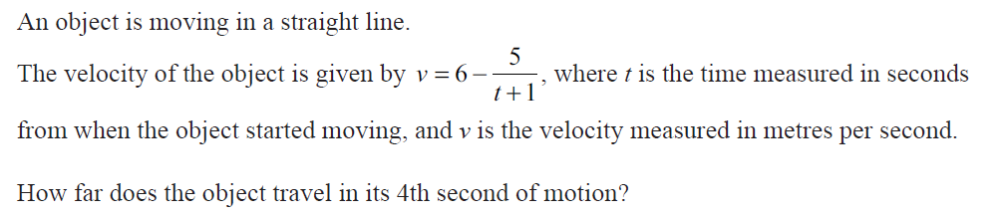

d = 6t – 5 ln(t + 1) + c
sub t = 4 d₁ = 24 – 5 ln(5) + c
sub t = 3 d₂ = 18 – 5 ln(4) + c

so Dist in 4th sec = d₁ – d₂ = 15.95 – 11.07 = 4.88 m

8
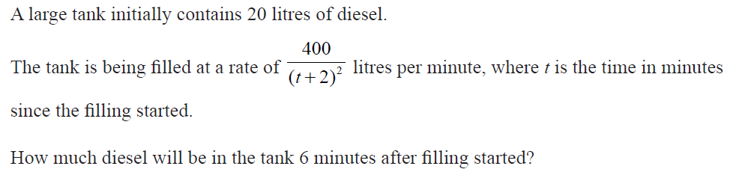
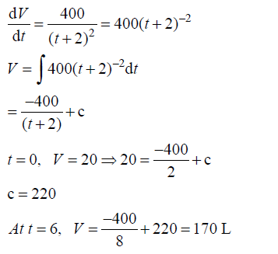

9
