Name………………………………………………….

MATHEMATICS WITH CALCULUS

2015

TIME ALLOWED: 3 hours

Show ALL working for ALL questions

If you need more space, use the back pages of each assessment.

Unless otherwise stated, 3 significant figure numerical answers will be adequate.

Mathematical formulae and tables are supplied.

Achievement Standard Assessment | Grade
Complex Numbers 91577 (3.5)

Differential Calculus 91578 (3.6)

Integral Calculus.91579 (3.7)

91577: Apply the algebra of Complex Numbers.

You are advised to spend 60 minutes answering the questions in this booklet.
Assessor’s
use only

QUESTION ONE

(a) Given that (x – 1) is a factor of 3cx³ – 4cx² – 8cx +18 = 0 find the value of c where c is real.
_____________________________________________________________________________________
_____________________________________________________________________________________
_____________________________________________________________________________________
_____________________________________________________________________________________
_____________________________________________________________________________________
_____________________________________________________________________________________
_____________________________________________________________________________________
(b) If u = 1 + i, find u⁸ in the polar form rcis(θ)

_____________________________________________________________________________________
_____________________________________________________________________________________
_____________________________________________________________________________________
_____________________________________________________________________________________
_____________________________________________________________________________________
_____________________________________________________________________________________

(c) Find any valid solutions of the equation:
You must show all your working steps. It is necessary to check the validity of your answers.

_____________________________________________________________________________________
_____________________________________________________________________________________
_____________________________________________________________________________________
_____________________________________________________________________________________
_____________________________________________________________________________________
_____________________________________________________________________________________
_____________________________________________________________________________________
_____________________________________________________________________________________

(d) Solve the equation z⁵ = 32ni in terms of n, where n is a real number and express
Assessor’s
use only
your solutions in polar form.
_____________________________________________________________________________________
_____________________________________________________________________________________
_____________________________________________________________________________________
_____________________________________________________________________________________
_____________________________________________________________________________________
_____________________________________________________________________________________
_____________________________________________________________________________________
_____________________________________________________________________________________
_____________________________________________________________________________________
_____________________________________________________________________________________
_____________________________________________________________________________________
_____________________________________________________________________________________
_____________________________________________________________________________________
_____________________________________________________________________________________
_____________________________________________________________________________________
_____________________________________________________________________________________
(e) Find the equation of the locus described by $|z+1+i|$ = $\left|z+2\right|$
_____________________________________________________________________________________
_____________________________________________________________________________________
_____________________________________________________________________________________
_____________________________________________________________________________________
_____________________________________________________________________________________
_____________________________________________________________________________________
_____________________________________________________________________________________
_____________________________________________________________________________________
_____________________________________________________________________________________
_____________________________________________________________________________________
_____________________________________________________________________________________
_____________________________________________________________________________________
_____________________________________________________________________________________
_____________________________________________________________________________________
_____________________________________________________________________________________

QUESTION TWO
(a) Solve the equation z² – 2z + 25 = 0 giving your solutions in the form a ± ib√c
Assessor’s
use only
where a, b and c are positive whole numbers and b ≠ 1

_____________________________________________________________________________________
_____________________________________________________________________________________
_____________________________________________________________________________________
_____________________________________________________________________________________
_____________________________________________________________________________________
_____________________________________________________________________________________

(b) Complex numbers u and v are represented on the Argand diagram.
If w = u show the position of w on Argand diagram below.
v
Im
u
v
Re

_____________________________________________________________________________________
_____________________________________________________________________________________
_____________________________________________________________________________________
_____________________________________________________________________________________
_____________________________________________________________________________________
_____________________________________________________________________________________
_____________________________________________________________________________________
_____________________________________________________________________________________
_____________________________________________________________________________________
(c) One root of v³ – 2v² – 3v + k = 0 is v = –1 + 2i
Find the value of k and the other two roots. (note: k is a real number)
Assessor’s
use only
_____________________________________________________________________________________
_____________________________________________________________________________________
_____________________________________________________________________________________
_____________________________________________________________________________________
_____________________________________________________________________________________
_____________________________________________________________________________________
_____________________________________________________________________________________
_____________________________________________________________________________________
_____________________________________________________________________________________
_____________________________________________________________________________________
_____________________________________________________________________________________

(d)(i) The complex number z satisfies the equation $\left|z-2+2i\right|=2$ where z = x + yi

Carefully draw the locus of z on the Argand diagram below.
Im
Re
(ii) What is the minimum value of Im(z) ?
_____________________________________________________________________________________
_____________________________________________________________________________________
_____________________________________________________________________________________

Assessor’s
use only
(e) If z = a + ib where b > a > 0 and arg(z) = – π show that a = – 2b
3 + i 2

_____________________________________________________________________________________
_____________________________________________________________________________________
_____________________________________________________________________________________
_____________________________________________________________________________________
_____________________________________________________________________________________
_____________________________________________________________________________________
_____________________________________________________________________________________
_____________________________________________________________________________________
_____________________________________________________________________________________
_____________________________________________________________________________________
_____________________________________________________________________________________
_____________________________________________________________________________________
_____________________________________________________________________________________
_____________________________________________________________________________________
_____________________________________________________________________________________
_____________________________________________________________________________________
_____________________________________________________________________________________
_____________________________________________________________________________________
_____________________________________________________________________________________
_____________________________________________________________________________________
_____________________________________________________________________________________
_____________________________________________________________________________________
_____________________________________________________________________________________
_____________________________________________________________________________________
_____________________________________________________________________________________
_____________________________________________________________________________________
_____________________________________________________________________________________
_____________________________________________________________________________________
_____________________________________________________________________________________

QUESTION THREE
(a) Expand (1 + √2)(3 – √2)² and express your answer in the form a + b√2
Assessor’s
use only
_______________________________________________________________________________
_______________________________________________________________________________
_______________________________________________________________________________
_______________________________________________________________________________
_______________________________________________________________________________
_______________________________________________________________________________
_______________________________________________________________________________
_______________________________________________________________________________
_______________________________________________________________________________

(b) If u = 8cis(5θ) and v = 4cis(3θ) write u in polar form.
v
_________________________________________________________________________
_________________________________________________________________________
________________________________________________________________________
_________________________________________________________________________
_________________________________________________________________________
(c) Find the exact value of $(\frac{1}{\sqrt{2}}- \frac{i}{\sqrt{2}}$)⁹ expressing your answer in the form a + ib
_________________________________________________________________________
_________________________________________________________________________
________________________________________________________________________
_________________________________________________________________________
______________________________________________________________________________
_________________________________________________________________________
________________________________________________________________________
_________________________________________________________________________
_________________________________________________________________________
____________________________________________________________________

(d) If z = x + iy and w = 1 show that w = x² – y² – 2xyi
Assessor’s
use only
z² (x² + y²)²
_________________________________________________________________________
_________________________________________________________________________
__________________________________________________________________________
_________________________________________________________________________
_________________________________________________________________________
_________________________________________________________________________
__________________________________________________________________________
_________________________________________________________________________
_________________________________________________________________________
_________________________________________________________________________
__________________________________________________________________________
_________________________________________________________________________
_________________________________________________________________________
__________________________________________________________________________

(e) a, b, c and d are the four roots of the quartic equation:
x⁴ + px³ + qx² + rx + t = 0 where p, q r and t are real numbers

(i) show that a + b + c + d = -p and abcd = t

_________________________________________________________________________
_________________________________________________________________________
__________________________________________________________________________
_________________________________________________________________________
_________________________________________________________________________
__________________________________________________________________________
_________________________________________________________________________
(ii) Hence show that 1 + 1 + 1 + 1 = – p
bcd acd abd abc t
__________________________________________________________________________
_________________________________________________________________________
_________________________________________________________________________
__________________________________________________________________________
_________________________________________________________________________
_________________________________________________________________________

91578: Apply differentiation methods in solving problems
You are advised to spend 60 minutes answering the questions in this booklet. Show all working.
Assessor’s
use only

QUESTION ONE

(a) Differentiate y = 8sin(4x) You do not need to simplify your answer.

________________________________________________________________________________________
_________________________________________________________________________________________
_________________________________________________________________________________________ ________________________________________________________________________________________
________________________________________________________________________________________
_______________________________________________________________________________________
(b) Find the gradient of the NORMAL to the curve y = (x³ + 2x)²
at the point (1, 9)

You must use calculus and clearly show your working, including any derivatives you need to
find when solving this problem.
______________________________________________________________________________________
_______________________________________________________________________________________
_____________________________________________________________________________________
_____________________________________________________________________________________
_____________________________________________________________________________________
_____________________________________________________________________________________
_____________________________________________________________________________________
_____________________________________________________________________________________
_____________________________________________________________________________________
_____________________________________________________________________________________
_____________________________________________________________________________________
_____________________________________________________________________________________
_____________________________________________________________________________________
_____________________________________________________________________________________
_____________________________________________________________________________________
_____________________________________________________________________________________
_____________________________________________________________________________________
_____________________________________________________________________________________

(c) If x = cos(2t) and y = 2sin(t) show that dy = – 1 .
Assessor’s
use only
dx sin(t)

You must use calculus and clearly show your working, including any derivatives you need to
find when solving this problem.
_____________________________________________________________________________________
_____________________________________________________________________________________
_____________________________________________________________________________________
_____________________________________________________________________________________
_____________________________________________________________________________________
_____________________________________________________________________________________
_____________________________________________________________________________________
_____________________________________________________________________________________
_____________________________________________________________________________________
_____________________________________________________________________________________
(d) A curve is defined by y = e ^{8 – 4x} + 4x
Find the x coordinates of any points on the curve where the gradient is zero.
_____________________________________________________________________________________
_____________________________________________________________________________________
_____________________________________________________________________________________
_____________________________________________________________________________________
_____________________________________________________________________________________
_____________________________________________________________________________________
_____________________________________________________________________________________
_____________________________________________________________________________________
_____________________________________________________________________________________
_____________________________________________________________________________________
_____________________________________________________________________________________
_____________________________________________________________________________________
_____________________________________________________________________________________
_____________________________________________________________________________________
_____________________________________________________________________________________
_____________________________________________________________________________________
_____________________________________________________________________________________

(e) If the slant height of a cone is 8√3 cm prove that the maximum volume
Assessor’s
use only
is when h = 8 cm and r = 8√2 cm
Volume of a cone = πr²h
3

h 8√3

r

Show any derivatives that you need to find when solving this problem.
(You may assume any 2nd derivative is < 0. )
_________________________________________________________________________
_________________________________________________________________________
_________________________________________________________________________
_________________________________________________________________________
_________________________________________________________________________
_________________________________________________________________________
_________________________________________________________________________
_________________________________________________________________________
_________________________________________________________________________
_________________________________________________________________________
_________________________________________________________________________
_________________________________________________________________________
_________________________________________________________________________
_________________________________________________________________________
_________________________________________________________________________
_________________________________________________________________________
_________________________________________________________________________
_________________________________________________________________________
_________________________________________________________________________
_________________________________________________________________________
_________________________________________________________________________
_________________________________________________________________________
_________________________________________________________________________
_________________________________________________________________________
_________________________________________________________________________
_________________________________________________________________________
_________________________________________________________________________
_________________________________________________________________________
_________________________________________________________________________
_________________________________________________________________________
_________________________________________________________________________
_________________________________________________________________________
_________________________________________________________________________
_________________________________________________________________________
_________________________________________________________________________
_________________________________________________________________________

QUESTION TWO
(a) (a) Differentiate y = ln(x² + 1) You do not need to simplify your answer.
Assessor’s
use only
Assessor’s
use only
3x + 4
_____________________________________________________________________________________
_____________________________________________________________________________________
_____________________________________________________________________________________
_____________________________________________________________________________________
_____________________________________________________________________________________
(b) Find the gradient of the tangent to the curve y = 3e^{2x – 8} where x = 4
Show any derivatives that you need to find when solving this problem.
_____________________________________________________________________________________
_____________________________________________________________________________________
_____________________________________________________________________________________
_____________________________________________________________________________________
_____________________________________________________________________________________
_____________________________________________________________________________________
(c) The graph below shows the piece-wise function y = f(x)
y 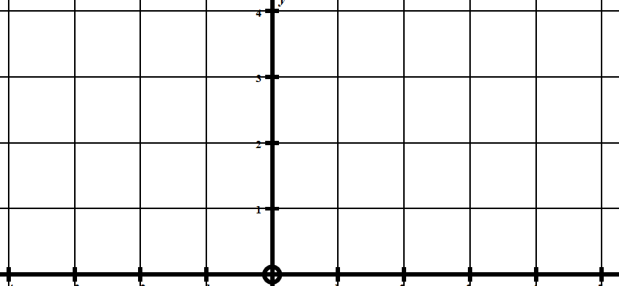 x
-4 -3 -2 -1 0 1 2 3 4 5
(i) For what x values is f(x) not continuous? _________________________________________________

(ii) For what x values is f(x) not differentiable? _________________________________________

(iii) For what x values is f(x) not defined? _________________________________________

(iv) What is lim f(x) _________________________________________
^{x 0}
(v) What is lim f(x) __________________________________________
^{x 1}
(vi) What is f(1) __________________________________________

Assessor’s
use only
(d) A type of fungus exists for a period of 15 days.
The volume Vcm³, of the fungus at t days is given by V = 16 – t – 16 .
(t + 1)
Find the maximum volume of the fungus.

Show any derivatives that you need to find when solving this problem.

_____________________________________________________________________________________
_____________________________________________________________________________________
_____________________________________________________________________________________
_____________________________________________________________________________________
_____________________________________________________________________________________
_____________________________________________________________________________________
_____________________________________________________________________________________
_____________________________________________________________________________________
(e) The curve below has the equation y = x² The units are in centimetres.
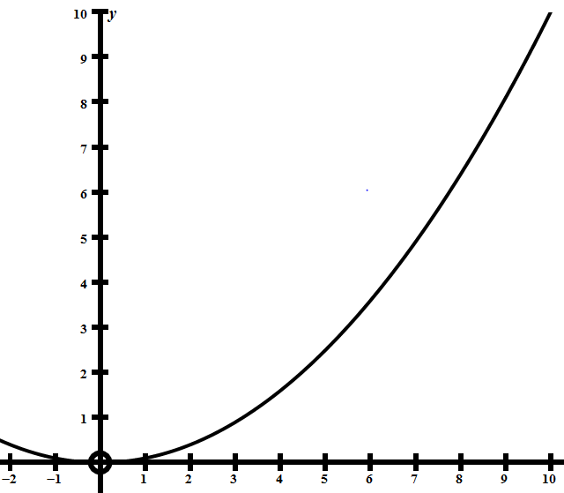
The point P moves along the x axis from x = 0 to x = 10 at a rate of 2 cm/sec.
The point S is on the curve y = x²
10
and is always vertically above P.
Find the rate at which the area of rectangle PQRS is changing when P is at x = 5 cm
Give any derivative(s) you need to find when solving this problem.
10
S
R
P Q
x
____________________________________________________________________________________________
___________________________________________________________________________________________
___________________________________________________________________________________________
___________________________________________________________________________________________
___________________________________________________________________________________________
___________________________________________________________________________________________
___________________________________________________________________________________________
___________________________________________________________________________________________
___________________________________________________________________________________________
___________________________________________________________________________________________
___________________________________________________________________________________________

QUESTION THREE
Assessor’s
use only
(a) Differentiate
You do not need to simplify your answer.

_____________________________________________________________________________________
_____________________________________________________________________________________
_____________________________________________________________________________________
_____________________________________________________________________________________
(b) Find any x values for which the function $y= \frac{x^{2}}{x-2}$ has stationary points.
Show any derivatives that you need to find when solving this problem.
_____________________________________________________________________________________
_____________________________________________________________________________________
_____________________________________________________________________________________
_____________________________________________________________________________________
_____________________________________________________________________________________
_____________________________________________________________________________________
_____________________________________________________________________________________
_____________________________________________________________________________________
_____________________________________________________________________________________
(c) For what values of x is the function y = xln(x) – 2x decreasing.
You must use calculus and clearly show your working, including any derivatives you need to
find when solving this problem.
_____________________________________________________________________________________
_____________________________________________________________________________________
_____________________________________________________________________________________
_____________________________________________________________________________________
_____________________________________________________________________________________
_____________________________________________________________________________________
_____________________________________________________________________________________
_____________________________________________________________________________________
_____________________________________________________________________________________
_____________________________________________________________________________________

(d) A meteor M, which has reached a terminal velocity of 90 m/s, is falling vertically
to the earth’s surface and will hit the ground at Q.
Assessor’s
use only
The meteor is being filmed by a camera at C.
The distance CQ is 800 metres.
M

θ
Q 800m C
Find the rate at which the camera is rotating when the meteor is at a height of 500m.

_____________________________________________________________________________________
_____________________________________________________________________________________
_____________________________________________________________________________________
_____________________________________________________________________________________
_____________________________________________________________________________________
_____________________________________________________________________________________
_____________________________________________________________________________________
_____________________________________________________________________________________
_____________________________________________________________________________________
_____________________________________________________________________________________
_____________________________________________________________________________________
_____________________________________________________________________________________
_____________________________________________________________________________________
_____________________________________________________________________________________
_____________________________________________________________________________________
_____________________________________________________________________________________
_____________________________________________________________________________________
_____________________________________________________________________________________
_____________________________________________________________________________________
_____________________________________________________________________________________

Assessor’s
use only
(e) ABC is an equilateral triangle with sides 20 cm long.
PQRS is a rectangle which fits inside the triangle as shown below.
A

S R

B P Q C
Find the dimensions and area of the largest rectangle which can fit inside triangle ∆ABC.

(You do not have to prove your value is a maximum. You may assume any 2nd derivative < 0)
_________________________________________________________________________
_________________________________________________________________________
_________________________________________________________________________
_________________________________________________________________________
_________________________________________________________________________
_________________________________________________________________________
_________________________________________________________________________
_________________________________________________________________________
_________________________________________________________________________
_________________________________________________________________________
_________________________________________________________________________
_________________________________________________________________________
_________________________________________________________________________
_________________________________________________________________________
_________________________________________________________________________
_________________________________________________________________________
_________________________________________________________________________
_________________________________________________________________________
_________________________________________________________________________
_________________________________________________________________________
_________________________________________________________________________
_________________________________________________________________________
_________________________________________________________________________
_________________________________________________________________________
_________________________________________________________________________
_________________________________________________________________________
_________________________________________________________________________
_________________________________________________________________________
_________________________________________________________________________
_________________________________________________________________________
_________________________________________________________________________

91579: Apply integration methods in solving problems

You are advised to spend 60 minutes answering the questions in this booklet.
Assessor’s
use only

QUESTION ONE

(a) Find the integrals:

You do not need to simplify your answers. Do not forget the constant of integration.

$\int{\frac{4}{x^{4}}- \frac{1}{x} dx}$

_____________________________________________________________________________________
_____________________________________________________________________________________
_____________________________________________________________________________________
_______________________________________________________________________________________

(b) Calculate
$$\int_{0}^{\frac{π}{2}}{sin\left(x\right)+cos\left(x\right) dx}$$
Give the results of any integration needed to solve this problem.
_____________________________________________________________________________________
_____________________________________________________________________________________
_____________________________________________________________________________________
_____________________________________________________________________________________
_____________________________________________________________________________________
_____________________________________________________________________________________
_____________________________________________________________________________________
_____________________________________________________________________________________
_____________________________________________________________________________________
_____________________________________________________________________________________
_____________________________________________________________________________________
_____________________________________________________________________________________
_____________________________________________________________________________________
_____________________________________________________________________________________
_____________________________________________________________________________________
_____________________________________________________________________________________

(c) The velocity v metres/sec, of an object at t sec is given by the equation:
v = 2t – $e^{(1-t)}$
Assessor’s
use only
Find the distance moved by the object from t = 1 to t = 4
Give the results of any integration needed to solve this problem.
_____________________________________________________________________________________
_____________________________________________________________________________________
_____________________________________________________________________________________
_____________________________________________________________________________________
_____________________________________________________________________________________
_____________________________________________________________________________________
_____________________________________________________________________________________
_____________________________________________________________________________________
_____________________________________________________________________________________
_____________________________________________________________________________________
_____________________________________________________________________________________
_____________________________________________________________________________________

(d) During a chemical reaction, the rate of decrease in mass m, of a substance
is proportional to $m^{\frac{1}{3}}.$
At the start of the reaction m = 8 g and at t = 2 hours, m = 1 g.
At what time will the substance have completely gone?

Give the results of any integration needed to solve this problem.

_____________________________________________________________________________________
_____________________________________________________________________________________
_____________________________________________________________________________________
_____________________________________________________________________________________
_____________________________________________________________________________________
_____________________________________________________________________________________
_____________________________________________________________________________________
_____________________________________________________________________________________
_____________________________________________________________________________________
_____________________________________________________________________________________
_____________________________________________________________________________________

(e) The graphs below have the equations y = (p²+1) – x² and y = p² where p > 1
Assessor’s
use only
x²
y
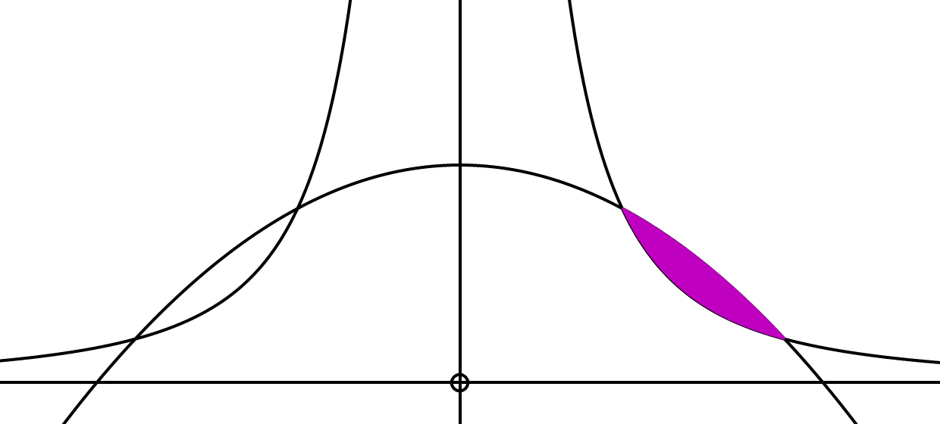x

(i) Show that the intersection points are x = ± 1 and x = ± p

(ii) Show that the shaded area is 2p³ – 2p² + 2p – 2
3 3

Give the results of any integrations needed to solve this problem.

_________________________________________________________________________
_________________________________________________________________________
_________________________________________________________________________
_________________________________________________________________________
_________________________________________________________________________
_________________________________________________________________________
_________________________________________________________________________
_________________________________________________________________________
_________________________________________________________________________
_________________________________________________________________________
_________________________________________________________________________
_________________________________________________________________________
_________________________________________________________________________
_________________________________________________________________________
_________________________________________________________________________
_________________________________________________________________________
_________________________________________________________________________
_________________________________________________________________________
_________________________________________________________________________
_________________________________________________________________________
_________________________________________________________________________
_________________________________________________________________________
_________________________________________________________________________
_________________________________________________________________________
_________________________________________________________________________
_________________________________________________________________________
_________________________________________________________________________
_________________________________________________________________________
_________________________________________________________________________
_________________________________________________________________________

QUESTION TWO
$$\int_{2}^{14}{f\left(x\right)dx}$$
Assessor’s
use only

(a) Use the values given in the table below to find an approximation to
using Simpson’s Rule.
x | 2 | 4 | 6 | 8 | 10 | 12 | 14
f(x) | 3 | 9 | 13 | 15 | 11 | 5 | 1
Give your answer correct to 3 significant figures.
_________________________________________________________________________
_________________________________________________________________________
_________________________________________________________________________
_________________________________________________________________________
_________________________________________________________________________
_________________________________________________________________________
_________________________________________________________________________
_________________________________________________________________________
_________________________________________________________________________
_________________________________________________________________________
_________________________________________________________________________
(b) Solve the differential equation $\frac{d^{2}y}{{dx}^{2}}=12x^{2 }+6x-4$
given that when x = 1, $\frac{dy}{dx}$ = 4 and y = 2
_________________________________________________________________________
_________________________________________________________________________
_________________________________________________________________________
_________________________________________________________________________
_________________________________________________________________________
_________________________________________________________________________
_________________________________________________________________________
_________________________________________________________________________
_________________________________________________________________________
_________________________________________________________________________
_________________________________________________________________________
_________________________________________________________________________
_________________________________________________________________________
_________________________________________________________________________
_________________________________________________________________________
_________________________________________________________________________
_________________________________________________________________________
_________________________________________________________________________
_________________________________________________________________________
_________________________________________________________________________
_________________________________________________________________________
_________________________________________________________________________
_________________________________________________________________________

Assessor’s
use only
(c) The equation of the graph below is $y =$ $\frac{8}{x}$
y
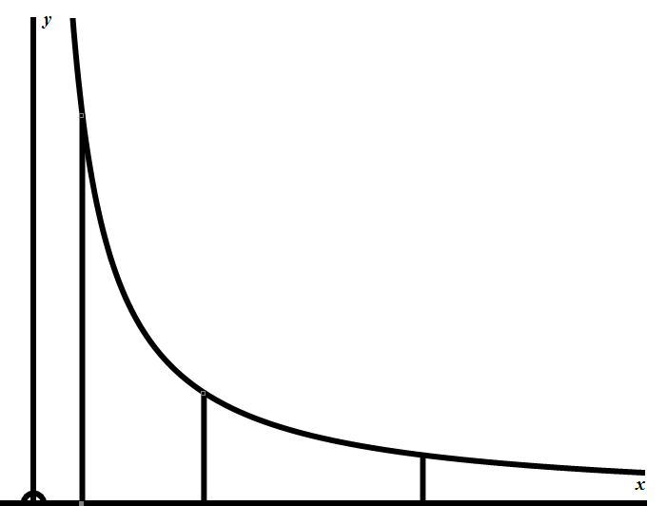
B
A
1 k 8 x

Find the value of k so that the areas A and B are equal.

_________________________________________________________________________
_________________________________________________________________________
_________________________________________________________________________
_________________________________________________________________________
_________________________________________________________________________
_________________________________________________________________________
_________________________________________________________________________
_________________________________________________________________________
_________________________________________________________________________
_________________________________________________________________________
_________________________________________________________________________
_________________________________________________________________________
_________________________________________________________________________
$$\frac{dy}{dx}=\frac{6y}{x^{3}}$$
(d) If and x = 1 when y = 1, find y when x = 2

_________________________________________________________________________
_________________________________________________________________________
_________________________________________________________________________
_________________________________________________________________________
_________________________________________________________________________
_________________________________________________________________________
_________________________________________________________________________
_________________________________________________________________________
_________________________________________________________________________
_________________________________________________________________________
_________________________________________________________________________
_________________________________________________________________________
_________________________________________________________________________
_________________________________________________________________________
_________________________________________________________________________
_________________________________________________________________________
_________________________________________________________________________
_________________________________________________________________________
(e)
Find the indefinite integral:
Assessor’s
use only
$$\int{\frac{dx}{1+ e^{-x}}}$$

Give the results of any integration needed to solve this problem.

_________________________________________________________________________
_________________________________________________________________________
_________________________________________________________________________
_________________________________________________________________________
_________________________________________________________________________
_________________________________________________________________________
_________________________________________________________________________
_________________________________________________________________________
_________________________________________________________________________
_________________________________________________________________________
_________________________________________________________________________
_________________________________________________________________________
_________________________________________________________________________
_________________________________________________________________________
_________________________________________________________________________
_________________________________________________________________________
_________________________________________________________________________
_________________________________________________________________________
_________________________________________________________________________
_________________________________________________________________________
_________________________________________________________________________
_________________________________________________________________________
_________________________________________________________________________
_________________________________________________________________________
_________________________________________________________________________
_________________________________________________________________________
_________________________________________________________________________
_________________________________________________________________________
_________________________________________________________________________
_________________________________________________________________________
_________________________________________________________________________
_________________________________________________________________________
_________________________________________________________________________
_________________________________________________________________________
_________________________________________________________________________
_________________________________________________________________________
_________________________________________________________________________
_________________________________________________________________________
_________________________________________________________________________

QUESTION THREE
Assessor’s
use only

(a) Find the integral:

$$\int{\frac{x^{\begin{aligned}4 \\ \\ \end{aligned}}+4x^{2}+8x}{x^{2}}} dx$$

You do not need to simplify your answers. Do not forget the constant of integration.

_____________________________________________________________________________________________
______________________________________________________________________________________________
______________________________________________________________________________________________
_____________________________________________________________________________________________
____________________________________________________________________________________________
____________________________________________________________________________________________
_____________________________________________________________________________________________
_____________________________________________________________________________________________
____________________________________________________________________________________________
____________________________________________________________________________________________
_____________________________________________________________________________________________

(b) Find the integral:
$$\int{\frac{\sqrt[5]{x^{\begin{aligned}4 \\ \\ \end{aligned}}}}{\sqrt[3]{x}}} dx$$

You do not need to simplify your answers. Do not forget the constant of integration.

_____________________________________________________________________________________________
______________________________________________________________________________________________
______________________________________________________________________________________________
_____________________________________________________________________________________________
____________________________________________________________________________________________
____________________________________________________________________________________________
_____________________________________________________________________________________________
_____________________________________________________________________________________________

Assessor’s
use only

(c) Evaluate the indefinite integral $\int{\frac{x^{2 }+4}{x+3}} dx$

_________________________________________________________________________
_________________________________________________________________________
_________________________________________________________________________
_________________________________________________________________________
_________________________________________________________________________
_________________________________________________________________________
_________________________________________________________________________
_________________________________________________________________________
_________________________________________________________________________
_________________________________________________________________________
_________________________________________________________________________
_________________________________________________________________________
_________________________________________________________________________
_________________________________________________________________________
_________________________________________________________________________
_________________________________________________________________________
_________________________________________________________________________
_________________________________________________________________________
_________________________________________________________________________
d) Evaluate the integral $\int_{2}^{7}{\frac{x-2 }{\sqrt{x+2}}} dx$
Give the results of any integration needed to solve this problem.

_________________________________________________________________________
_________________________________________________________________________
_________________________________________________________________________
_________________________________________________________________________
_________________________________________________________________________
_________________________________________________________________________
_________________________________________________________________________
_________________________________________________________________________
_________________________________________________________________________
_________________________________________________________________________
_________________________________________________________________________
_________________________________________________________________________
_________________________________________________________________________
_________________________________________________________________________
_________________________________________________________________________
_________________________________________________________________________
_________________________________________________________________________

Assessor’s
use only
(e) Radioactive waste is stored in lead containers until the radioactivity
decays to a safe level.
The rate of decay of this particular isotope is proportional to the amount
of radiation the isotope already has.
At t = 100 days, the radiation was checked and found to be 150 curies.
At t = 200 days, the radiation was checked again and found to be 90 curies.
The radioactive waste will be relatively safe when the radiation has
reached 20 curies or less.
Find how long this will take.

_________________________________________________________________________
_________________________________________________________________________
_________________________________________________________________________
_________________________________________________________________________
_________________________________________________________________________
_________________________________________________________________________
_________________________________________________________________________
_________________________________________________________________________
_________________________________________________________________________
_________________________________________________________________________
_________________________________________________________________________
_________________________________________________________________________
_________________________________________________________________________
_________________________________________________________________________
_________________________________________________________________________
_________________________________________________________________________
_________________________________________________________________________
_________________________________________________________________________
_________________________________________________________________________
_________________________________________________________________________
_________________________________________________________________________
_________________________________________________________________________
_________________________________________________________________________
_________________________________________________________________________
_________________________________________________________________________
_________________________________________________________________________
_________________________________________________________________________
_________________________________________________________________________
_________________________________________________________________________
_________________________________________________________________________
_________________________________________________________________________
_________________________________________________________________________
_________________________________________________________________________
_________________________________________________________________________
_________________________________________________________________________

