WHISKAS CAT FOOD USES THE IDEAL CAN.

(Volume V = πr²h Surface area S = 2πr² + 2πrh)

The problem is, “What are the values of r and h so that the surface area S is as small as possible but the volume is still 708.8 cm³?”

r If the radius is r and the height is h
h then V = πr²h = 708.8
so that h = 708.8
πr²

The surface area S = 2πr² + 2πrh
= 2πr² + 2πr×708.8 d
πr²
= 2πr² + 2×708.8 r ^{– 1}
dS = 4πr – 2×708.8 r ^{– 2} = 0 for min S
dr
4πr – 2×708.8 = 0 h
r²
4πr = 2×708.8
r²
r³ = 2×708.8
4π
So r = 4.83 and h = 708.8 = 9. 7
π×3.993²
rounding sensibly:
r ≈ 4.83 cm and h = 708.8 ≈ 9.7 cm
π4.83²

The ideal can which uses the least amount of metal
has the same HEIGHT as its DIAMETER!

Note: A lot of money could be saved by manufacturers because they could use less metal to hold the same volume.
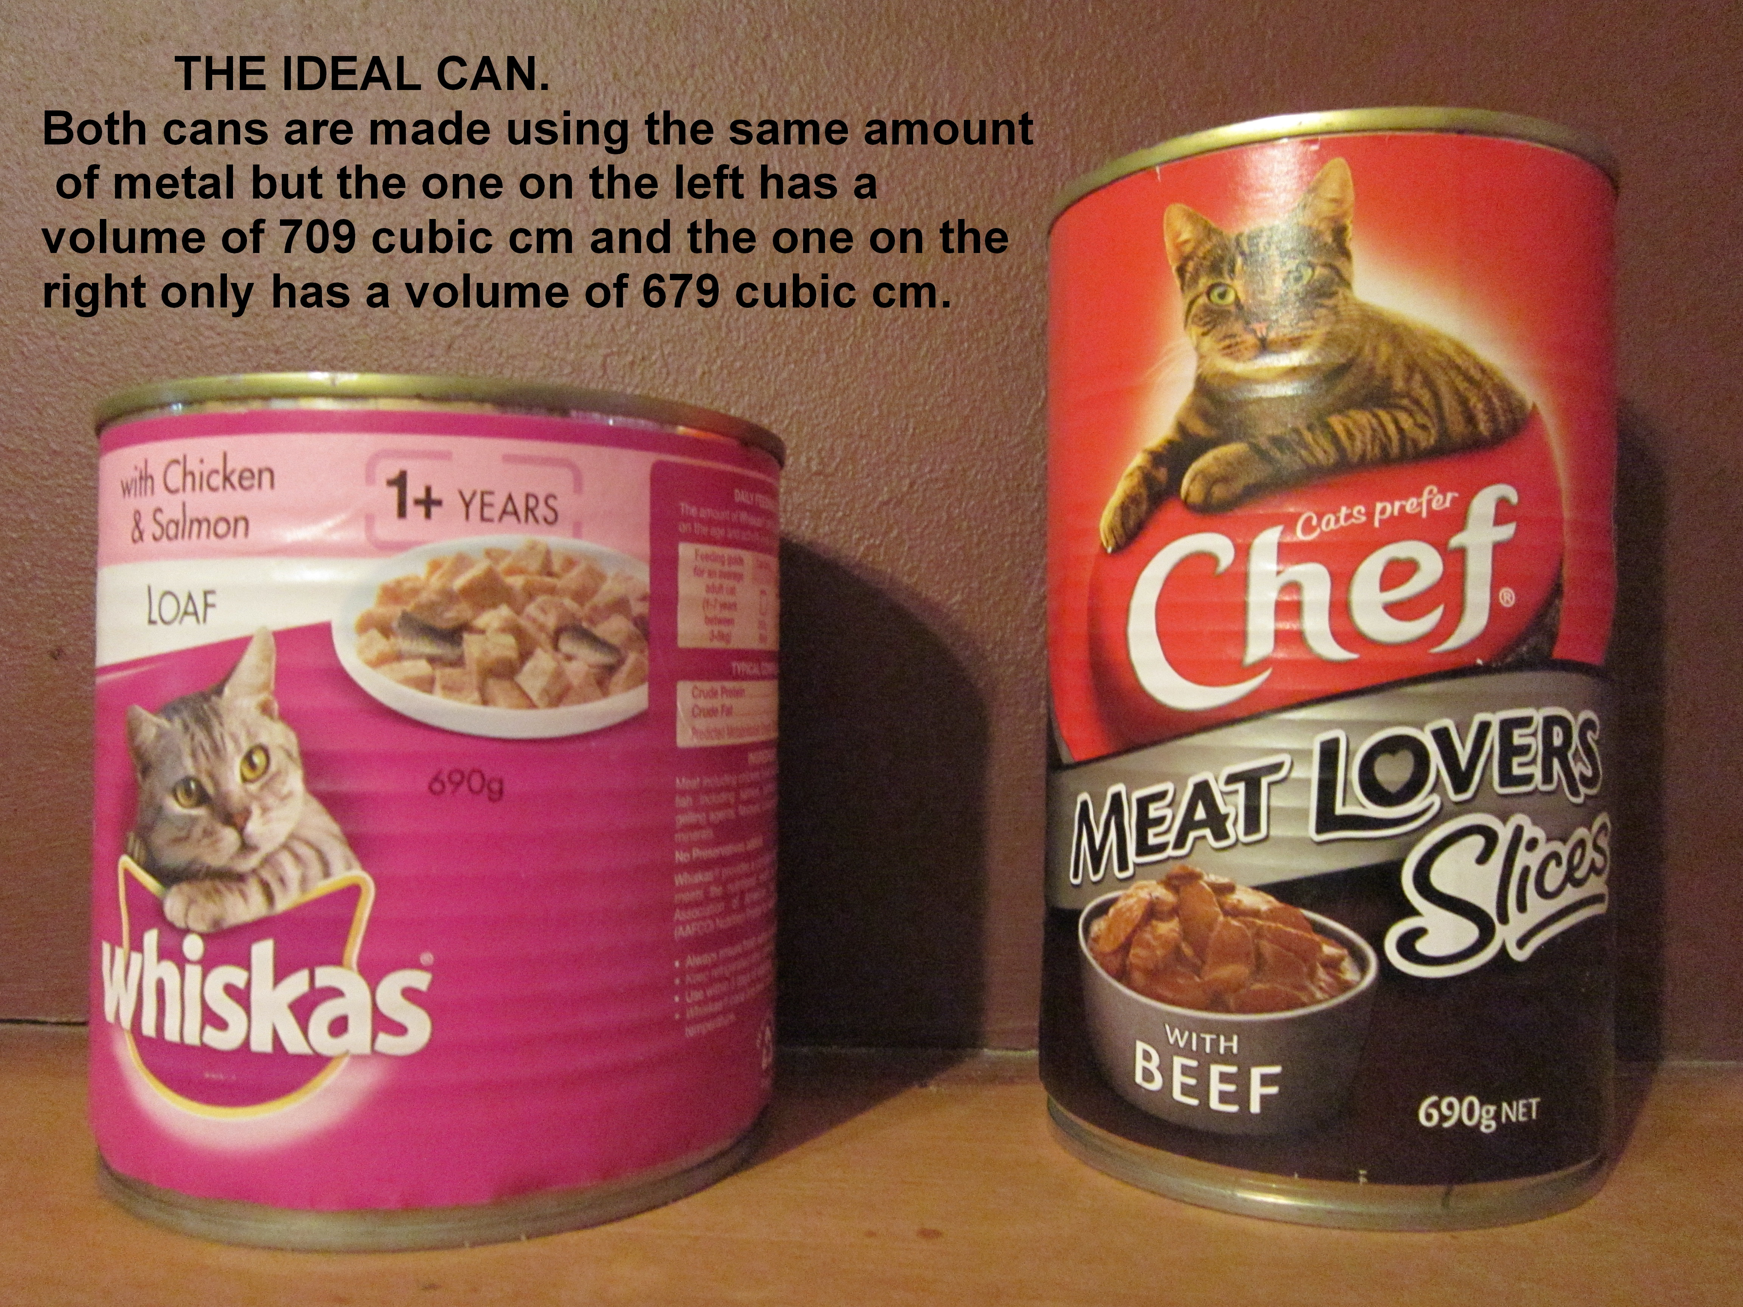

EXTENSION 1

GENERALLY : If the volume to be used is V then:
V = πr²h so h = V
πr²

The surface area S = 2πr² + 2πrh
= 2πr² + 2πr×V
πr²
= 2πr² + 2V r ^{– 1}
dS = 4πr – 2Vr ^{– 2} = 0 for min S
dr
4πr – 2V = 0
r²
4πr = 2V
r²
r³ = V
2π
So r = V ^{⅓} and diameter = 2r = 2× V ^{⅓} = = V ^{⅓} ×2^{⅔}
(2π)^{⅓} (2)^{⅓} (π)^{⅓} π^{⅓}

and h = V
πr²
= V × (2π)^{⅔}
π V^{⅔}
= V ^{⅓} ×2^{⅔}
π^{⅓}

The ideal can which uses the least amount of metal
has the same HEIGHT as its DIAMETER!

