AN UNUSUAL PROOF ON 2014 COMPLEX NUMBER ASSESSMENT.

If u = x + iy and au² + bu + c = 0, prove that a u ² + b u + c = 0
I do remember teaching this type of problem perhaps over 30 years ago.

The “model” answer gave the following:
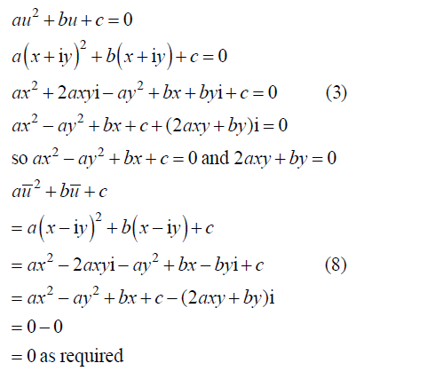
_______________________________________________________________

However a most elegant “proof” is as follows:

If au² + bu + c = 0 + 0i
then the conjugate of both sides must be true:

au² + bu + c = 0 + 0i

au² + bu + c = 0 – 0i

a ( u ²) + b ( u ) + c = 0 – 0i

a( u ) ² + b ( u ) + c = 0 – 0i

The only slight problem being that I stated that the conjugate of ( u² )
is the conjugate of u then squared!

ie ( u² ) = ( u )²
To verify this, I suppose we should compare:

(x + iy)² = (x² – y²) + 2xyi = (x² – y²) – 2xyi

and ( x + iy )² = ( x – iy )² = (x² – y²) – 2xyi

___________________________________________________________

Alternatively, surely we could have proceeded as follows:

The solution of au² + bu + c = 0 by the quadratic formula is:

u = – b ± √ (b² – 4ac)
2a

Since we are talking about complex roots we assume b² – 4ac is negative
so let b² – 4ac = – p²
then u = – b ± √ (– p² )
2a
= – b ± pi
2a
ie both roots – b + pi and – b – pi will satisfy the equation.
2a 2a

These roots are obviously complex conjugates equivalent to

u = x + iy and u = x – iy

Hence if u = x + iy and au² + bu + c = 0, then a u ² + b u + c = 0

