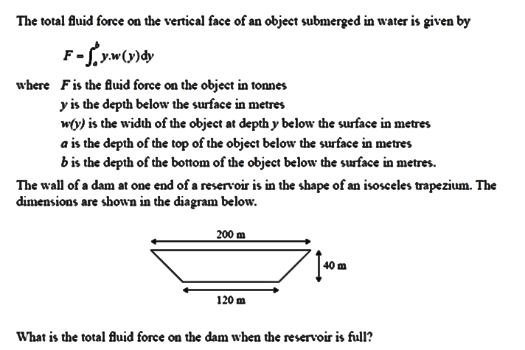
We need to find an expression for the width w, when the depth is h.

40 120 40

40

By similar triangles h
x
40 – h = 40 = 1
x 40
40 – h
So x = 40 – h

So the width at depth h
= x + x + 120 = 2x + 120 = 80 – 2h + 120 = 200 – 2h

$$\int_{0}^{40}{y\left(200-2y\right)dy}$$
F =

$$\int_{0}^{40}{200y-2y^{2 } dy}$$

40
= 100y² – 2 y³ = 117,333.3 tonnes
3
0

