10
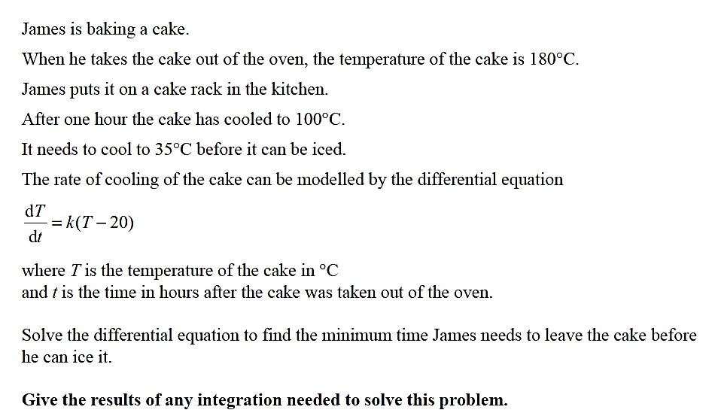

Subs t = 0, T = 180 so ln(160) = c

ln( T – 20) – ln(160) = kt

ln T – 20 = kt
160

Subs t = 1, T = 100 so ln 80 = k and k = -0.6931
160

ln T – 20 = 0.6931 t EQU 1
160

T – 20 = 160 e ^{0.6931t}

T = 20 + 160 e ^{0.6931t}

Subs T = 35 in EQU 1: ln 15 = 0.6931t
160
so t = 3.415 hours from when the cake was taken out of the oven before it can be iced. (3.415 hours ≈ 3 hr 25 min)

10

10

