An Interesting Investigation.
Consider the graphs:
y = 1 y = 1 y = e^{x}
x x²
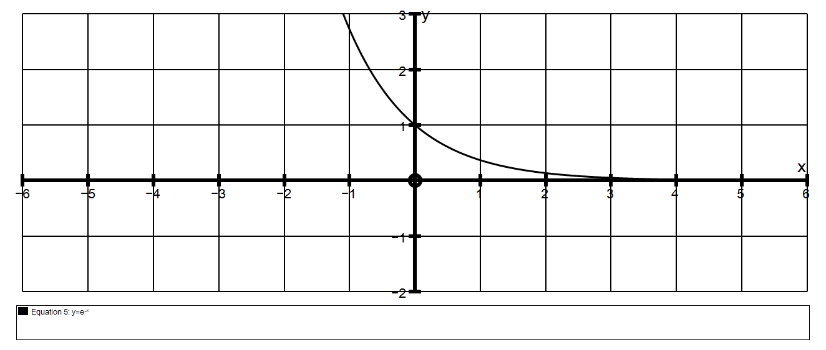
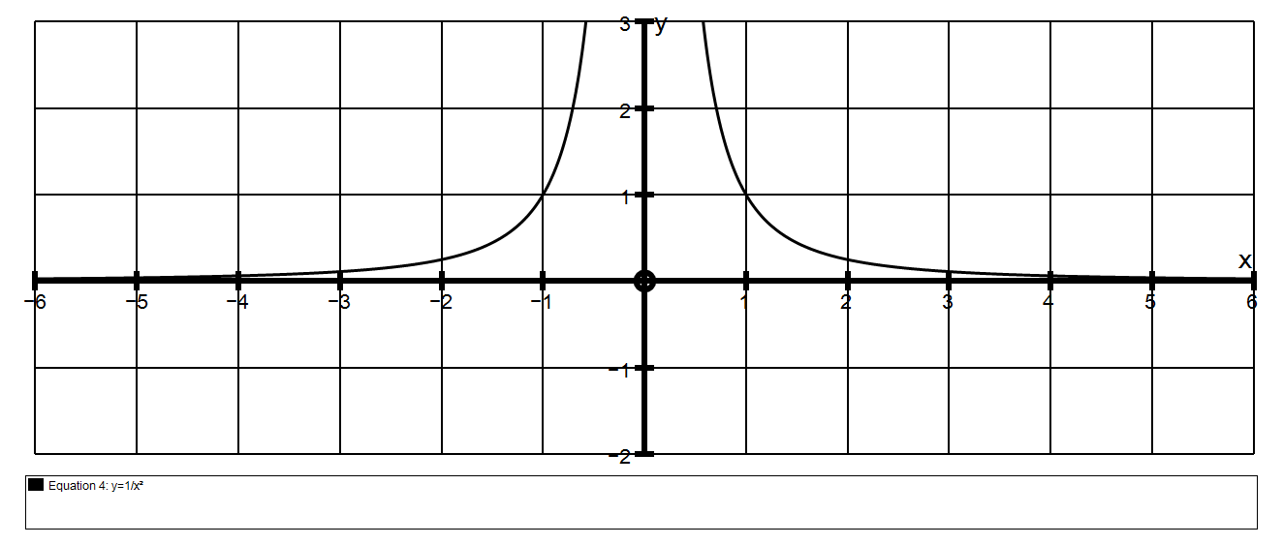
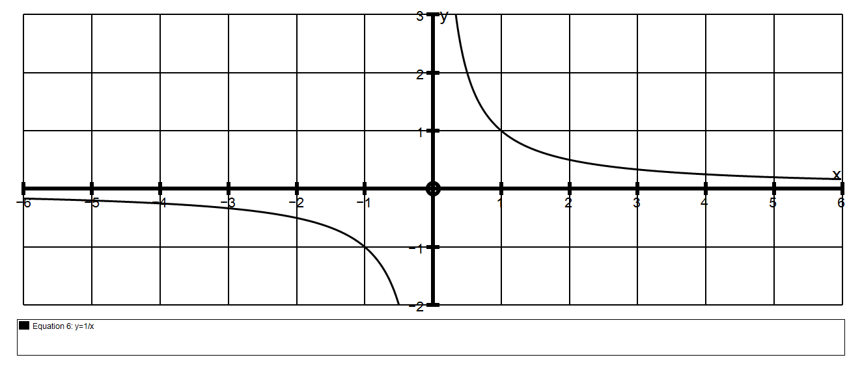

1. Suppose we want the area between the curve y = 1 and the x axis from 1 to b
x
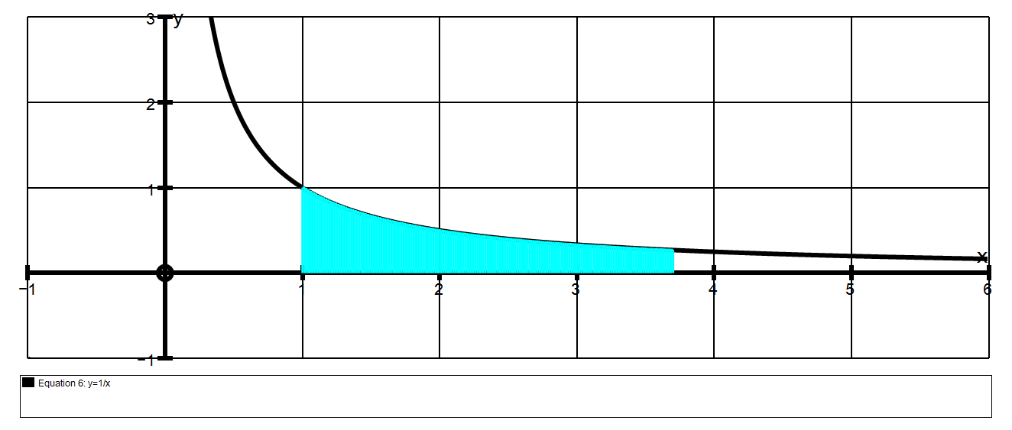
b
$$\int_{1}^{b}{\frac{1}{x}} dx$$
b
= ln(x)
1
= ln(b) – ln(1)
= ln(b) – 0
= ln(b)

b | 2 | 10 | 100 | 1000 | 10⁹⁹
Area | .69 | 2.3 | 4.6 | 6.9 | 228

We can see that the area just keeps on getting bigger and bigger.

We say it “increases without bound” which means it approaches infinity.

We could write this as Area $∞$

2. Suppose we want the area between the curve y = 1 and the x axis from 1 to b
x²
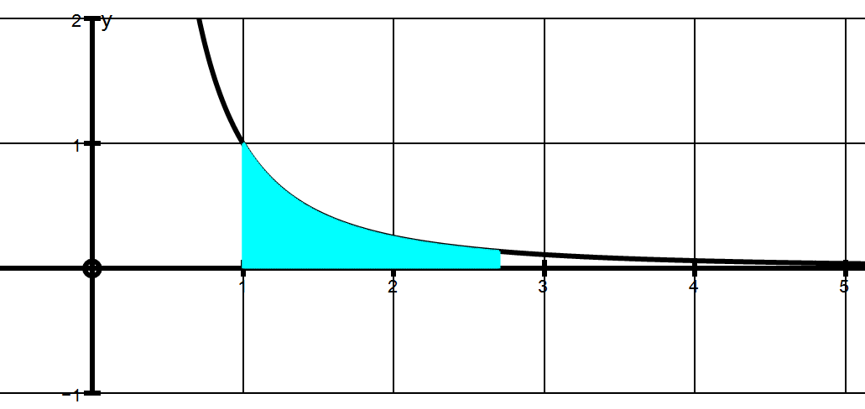
$$\int_{1}^{b}{\frac{1}{x^{2}}} dx$$
b
= – 1 = ( – 1 ) – ( –1)
x b
1
= 1 – 1
b

b

b | 2 | 10 | 100 | 1000 | 1000000
Area | 0.5 | 0.9 | 0.99 | 0.999 | 0.999999

Clearly the area is increasing but it is approaching a LIMIT of 1.
If we examine the expression A = 1 – 1
b
we can see that as b gets bigger, 1 gets smaller. lim 1 0
b b$∞$ b

3. Suppose we want the area between the curve y = e ^{– x} and the x axis from 0 to b
$$\int_{0}^{b}{e^{-x} dx}$$
b
= – e ^{– x} = – e ^{–b} – (– e ⁰)
0

= 1 – 1
e^{b}
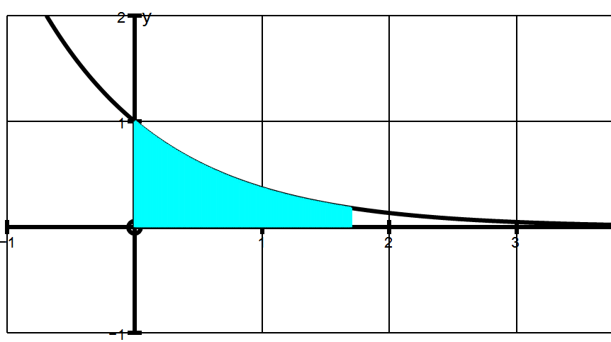

b | 2 | 5 | 10 | 12 | 15
Area | 0.86466 | 0.9932 | 0.9999546 | .99999385 | .99999969

Clearly the area is increasing but it is also approaching a LIMIT of 1.
If we examine the expression A = 1 – 1
e^{b}
we can see that as b gets bigger, 1 gets smaller. lim 1 0 quickly
e^{b} b$∞$ e^{b}

EXTENTION.
Although the area under y = 1 from 1 to $∞$ approaches 1
x²
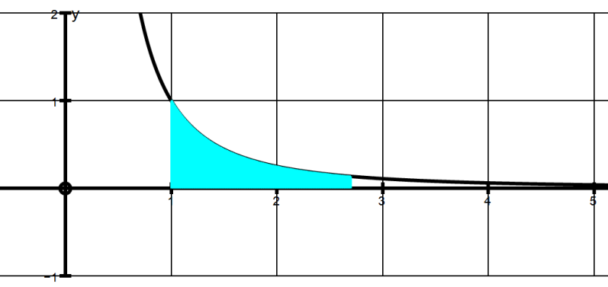

…the area from zero to 1 does not approach a limit.

Consider the area from x = b to x = 1

$$\int_{b}^{1}{\frac{1}{x^{2}}} dx$$

1
= – 1 = ( – 1) – ( – 1 )
x b
b
= 1 – 1
b

b | 0.5 | 0.1 | 0.01 | 0.0001 | 0.000001
Area | 1 | 9 | 99 | 9999 | 999999

We can see that the area just keeps on getting bigger and bigger.

This area “increases without bound” which means it approaches infinity.

We could write this as Area $∞$ even though the area to the right of
x =1 approaches a limit of 1.

