CUBICS which factorise as well as their derivatives.

It is hard to find a cubic f(x) which factorises AND its derivative f ꞌ(x) also factorises too!
Here are a few I discovered:

1. y = x(x + 9)(x – 15)
= x(x² – 6x – 135)
= x³ – 6x² – 135x
y ꞌ = 3x² – 12x – 135
= 3(x² – 4x – 45)
= 3(x + 5)(x – 9)

2. y = x(x – 3)(x – 8) also (x + 3)x(x – 5) just by translating 3 to the left.
y = x(x² – 11x + 24)
y = x³ – 11x² + 24x
y ꞌ = 3x² – 22x + 24
= (3x – 4)(x – 6)

3. y = x(x – 9)(x – 24)
y = x(x² – 33x + 216)
y = x³ – 33x² + 216x
y ꞌ = 3x² – 66x + 216
= 3(x² – 22x + 72)
= 3(x – 4)(x – 18)

4. y = (2x – 5)(x – 1)²
y = 2x³ – 9x² + 12x – 5
y ꞌ = 6x² – 18x + 12
= 6(x² – 3x + 2)
= 6(x – 1)(x – 2)

5. Very common ones are like y = x(x – 3)² where the min is obviously at x = 3
y = x³ – 6x² + 9x
y ꞌ = 3x² – 12x + 9
y ꞌ = 3(x² – 4x + 3)
= 3(x – 1)(x – 3)

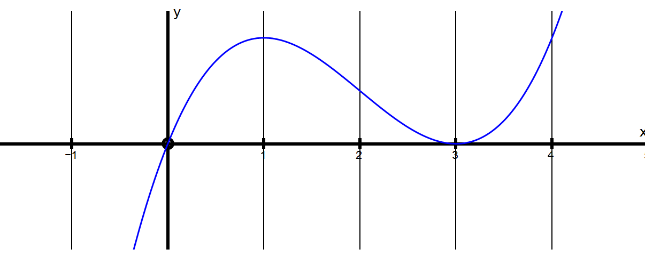
5. y = (x – 5)(x – 2)² which of course is just y = x²(x – 3) moved along 2

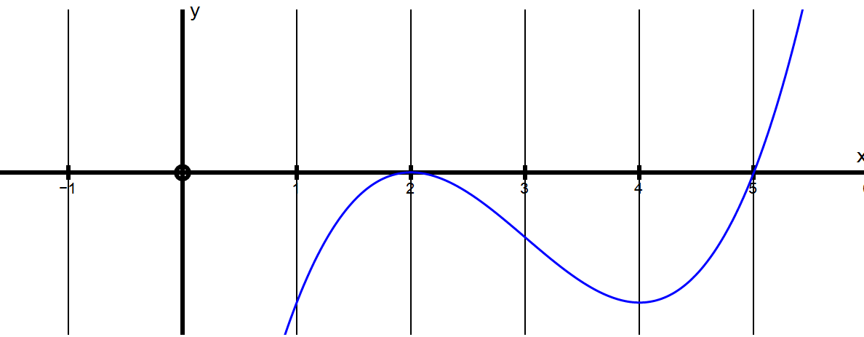

6. y =(x – 1)(x – 4)² which of course is just y = x(x – 3)² moved along 1

