CHEAT’S WAY TO DIFFERENTIATE: y = sin x
y = sin x
Grad=0
Grad=0
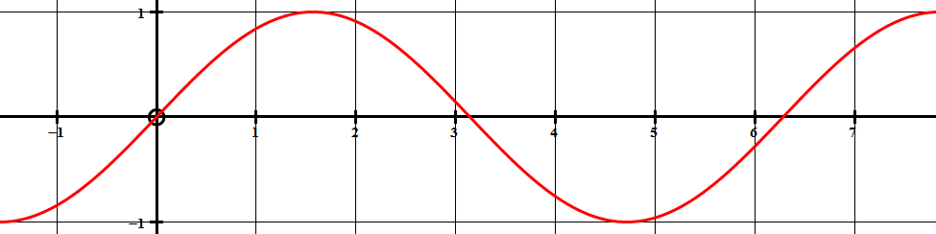
Grad= – 1
Grad=1
Grad=1
Grad=0
Grad=0
2π

3π
2

π

π
2

We find the gradients of y = sin x
at x = – π , 0 , π , π , 3 π , 2π
2 2 2
and plot these points on the gradient graph below…
yꞌ

2π

3π
2

π

-π
2

π
2

Filling in the gaps between these
points we get the graph yꞌ = cos x
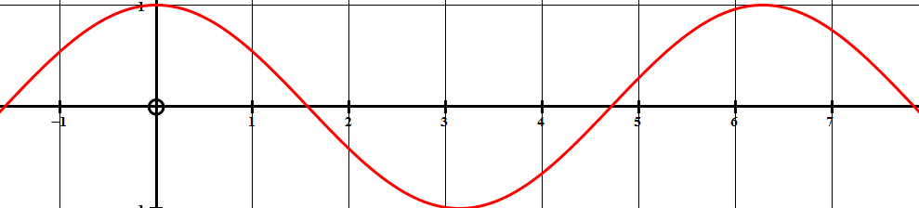
-π
2

2π

3π
2

π

π
2

As long as the scales are BOTH in RADIANS, we see that
the gradient graph of y = sin x is of course y ꞌ = cos x

