PARALLEL EXAM QUESTIONS
1.
$$\int{\sqrt{x } - \frac{3}{x}} - \frac{5}{x^{2}} dx$$

2.
$$\int{cos3x+\sec^{2}}5x+{cosec}^{2}7x dx$$

3.
$$\int{\frac{{(x}^{6}+x^{5}+x^{4}+x^{3}+x^{2})dx }{x^{4}}}$$

4. Find the area between y = x and y = b from x = 2 to point P.
b x

P

2

5. Sole the differential equation d²x = 6t + 4
dt²
given that at t = 2, dx = 5 and x = 10
dt

6. Find the area between y = 3x – 6 and the x axis from x = 4 to x = 6
x + 2

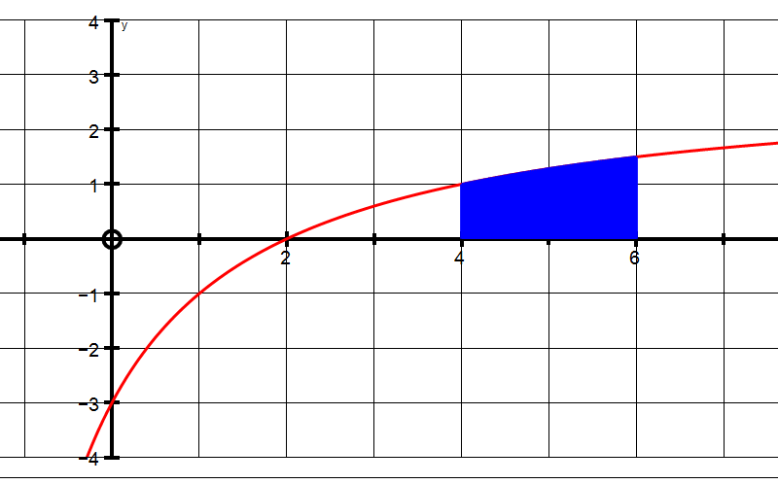

7. Find the integral using a suitable substitution.

$$\int{\frac{5x-9}{{(x-2)}^{2}}} dx$$

8. Find the integral using a suitable substitution.

$$\int{(x+3)\sqrt{(x-3)}} dx$$

