PARALLEL EXAM QUESTIONS
1.
$$\int{\sqrt{x } - \frac{3}{x}} - \frac{5}{x^{2}} dx$$

$$=\frac{2}{3}x^{\frac{3}{2}}-3lnx+\frac{5}{x}+c$$

2.
$$\int{cos3x+\sec^{2}}5x+{cosec}^{2}7x dx$$

$$=\frac{sin3x}{3}+\frac{tan5x}{5}-\frac{cot7x}{7}+c$$

3.
$$\int{\frac{{(x}^{6}+x^{5}+x^{4}+x^{3}+x^{2})dx }{x^{4}}}$$
= $\int{x^{2}+x+1+\frac{1}{x}+\frac{1}{x^{2}}}$ dx
$$= \int{x^{2}+x+1+x^{-1}+x^{-2}} dx$$
$$=\frac{x^{3}}{3}+\frac{x^{2}}{2}+x+lnx-\frac{1}{x}+c$$

4. Find the area between y = x and y = b from x = 2 to point P.
b x

P

2 b

$$\frac{x}{b}=\frac{b}{x} x^{2}=b^{2} x=b (where the 2 graphs intersect)$$
$$=\int_{2}^{b}{ \begin{aligned}\frac{b}{x}-\frac{x}{b} dx =\left[b lnx-\frac{x^{2}}{2b}\right] \\ \end{aligned}}$$
$=b lnb-\frac{b^{2}}{2b}-\left[b ln2-\frac{2^{2}}{2b}\right] =b lnb-\frac{b}{2}-b ln2+\frac{2}{b} =b\ln\left(\frac{b}{2}\right)-\frac{b}{2}+\frac{2}{b}$

5. Solve the differential equation d²x = 6t + 4
dt²
given that at t = 2, dx = 5 and x = 10
dt

$$\frac{dx}{dt}= \int{6t+4 dt =3t^{2}+4t+c}$$
$$5=3 ×2^{2} +4 ×2+c 5=20+c c= -15$$
$$\frac{dx}{dt}=3t^{2}+4t-15$$
$$x={\int{3t^{2}+4t-15 dt = }t}^{3}+2t^{2}-15t+c$$
$$10=2^{3}+2 ×2^{2}-15 ×2+c 10= -14+c c=24$$

$$x=t^{3}+2t^{2}-15t+24$$

6. Find the area between y = 3x – 6 and the x axis from x = 4 to x = 6
x + 2

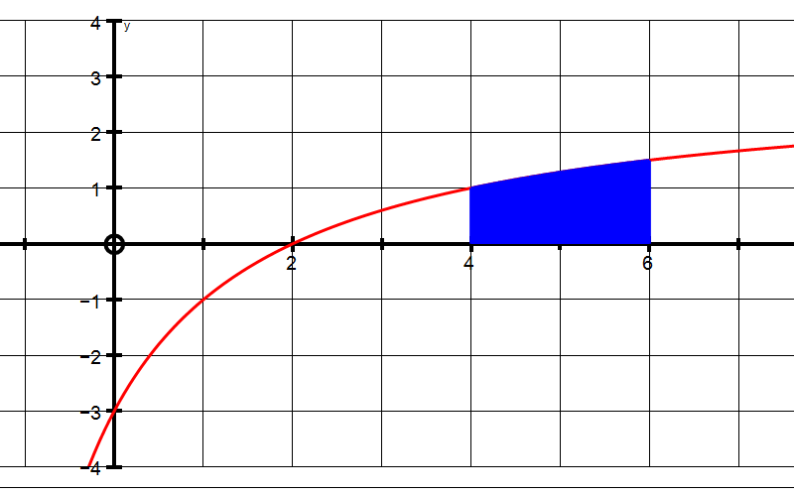

$$Carry out the division and you get= \int_{4}^{6}{3-\frac{12}{x+2}dx}$$
$$=\left[3x-12\ln\left(x+2\right)\right]$$
$$=\left[3×6-12\ln\left(8\right)\right]-\left[3×4-12\ln\left(6\right)\right]= -6.95+9.5 =2.55 units^{2}$$

7. Find the integral using a suitable substitution.

$$\int{\frac{5x-9}{{(x-2)}^{2}}} dx$$

$$Substitute u=x-2, you will also get x=u+2, and du=dx$$

$$Substitute this information into the original equation:$$

$$\int{\frac{5\left(u+2\right)-9}{u^{2}} du = \int{\frac{5u+1}{u^{2}}du = \int{\frac{5}{u}+\frac{1}{u^{2}} du}}}$$

$$=5 lnu-\frac{1}{u}+c =5\ln\left(x-2\right)-\frac{1}{x-2}+c$$

8. Find the integral using a suitable substitution.

$$\int{(x+3)\sqrt{(x-3)}} dx$$

$$Substitute u=x-3, you will also get x=u+3$$

$$so, dx=du =\int{(u+6})u^{\frac{1}{2}} du = \int{\left(u^{\frac{3}{2}}+6 u^{\frac{1}{2}}\right) du }$$
$$= \frac{2}{5} u^{\frac{5}{2 }}+4u^{\frac{3}{2}}+c$$
$$= \frac{2}{5} {(x-3)}^{\frac{5}{2 }}+4{(x-3)}^{\frac{3}{2}}+c$$

