THE FUNDAMENTAL THEOREM OF CALCULUS.
There are TWO different types of CALCULUS:
1. DIFFERENTIATION: finding gradients of curves.
2. INTEGRATION: finding areas under curves.

To estimate this area: We could split it into strips as below:
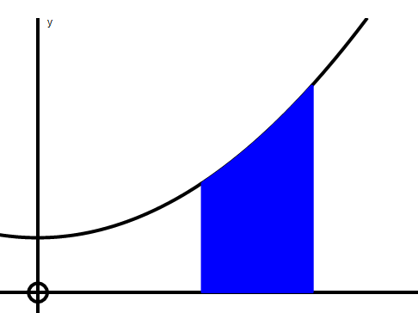
We neglect these little “triangular” bits and treat them as rectangles.
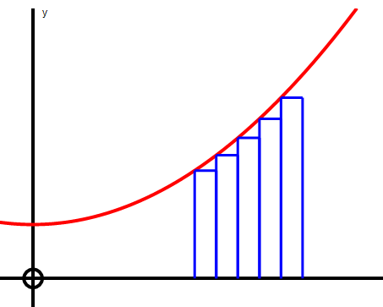

To get better approximations we We can see the approximation
could split the area into more strips: gets better and better as we use
more and more strips:
The little “triangular” bits become more and more negligible.
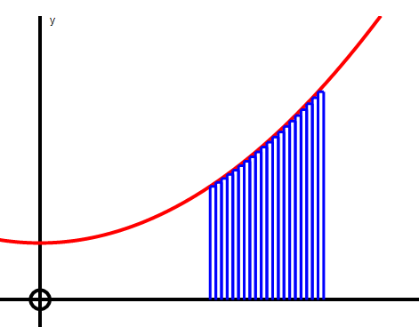
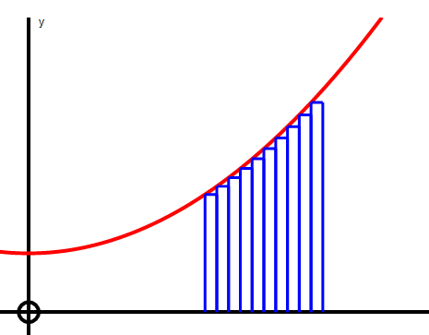

The sum of the areas of these strips gets closer and closer to the actual area under the curve. We can find this limit as follows:
Consider one strip greatly enlarged for clarity.
We will neglect the curved triangular bit on the top and treat the strip as a rectangle of height f(x) and width h.

Area of 1 strip ≈ f(x) × h
f(x)
Area of all strips ≈ ∑ f(x) × h
h
Actual area under the curve = lim ∑ f(x)×h which is written as ∫ f(x) dx
^{h→0}
NB At this stage the sign ∫ only means the limit of the sum of the strips.
There is no indication yet that ∫ has anything to do with antidifferentiation.

Suppose there exists a “formula” or expression, in terms of x, to find the area. (just like there is a formula to find the area of a circle = πr².)

We will call this formula or function A(x).
It is most helpful to think of this in the following way:

A(x₁) = area under the curve from x = 0 to x = x₁
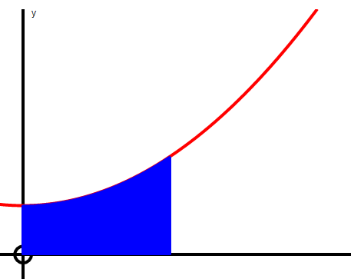
0 x₁
A(x₁)

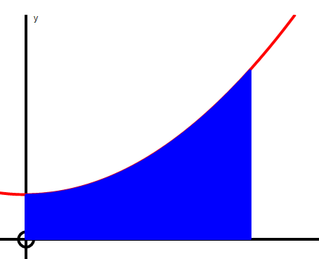
0 x₂
A(x₂) = area under the curve from x = 0 to x = x₂
A(x₂)

x₁ x₂
So the area from x₁ to x₂ could
be written as A(x₂) – A(x₁)

________________________________________________________Now consider just one of these strips mentioned earlier. (greatly enlarged)

F E

The area of the strip could be written as : D C
A(x+h) – A(x)
f(x) f(x+h)
The area of the strip is between the areas of the
rectangles ABCD and ABEF:
area ABCD < A(x + h) – A(x) < area ABEF

h

f(x)×h < A(x + h) – A(x) < f(x + h)×h A B

Dividing throughout by h, we get:

f(x) < A(x+h) – A(x) < f(x+h)
h
If we find the limit of this as h 0, the three quantities become equal because the two outer quantities both become f(x).

lim f(x) < lim A(x+h) – A(x) < lim f(x+h)
h→0 h→0 h ^{h→0}

So that: f(x) < dA < f(x)
dx

Obviously dA = f(x)
dx

In words, this says,
“ If we DIFFERENTIATE the expression for the AREA we get the
EQUATION of the curve.”

Or in other words,
“The formula for AREA is the ANTIDERIVATIVE of the
equation of the curve.”

Finding the área under a curve using “the limit of the sum of the strips” as previously explained, is a very complicated algebraic experience but we have just shown that the sign ∫ not only means “the limit of the sum of the strips” but it also means antidifferentiate.
b

a
Area A = ∫ f(x) dx now means:

Find the antiderivative of f(x) = A(x) then calculate A(b) – A(a)
₄

₂
eg if y = f(x) = 3x² and a = 2 and b = 4 then Area A = ∫ 3x² dx
4
= x³ = 4³ – 2³ = 64 – 8 = 56 units²
2

EDIT. An example of integrating y = x² from x = 0 to x = 3 by splitting the area into strips is shown below:

